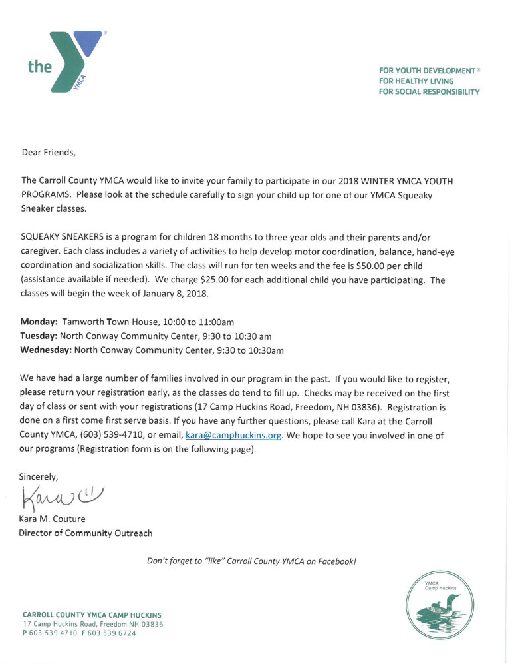

2018 CARROLL COUNTY YMCA REGISTRATION FORM

CHILD’S NAME________________________ AGE_______ BIRTH DATE_________________

PARENT’S NAME__________________________ CELL PHONE________________________

MAILING ADDRESS__________________________________________________________

EMAIL ADDRESS_____________________________________________________________

MY CHILD WOULD LIKE TO PARTICIPATE IN THE FOLLOWING YMCA PROGRAM (PLEASE CHECK)

____ SQUEAKY SNEAKERS ON MONDAY at the Tamworth Town House (10:00 to 11:00am)

____ SQUEAKY SNEAKERS ON TUESDAY at the North Conway Community Center (9:30 to 10:30am)

____ SQUEAKY SNEAKERS ON WEDNESDAY at the North Conway Community Center (9:30 to 10:30am)

**Please email this registration form to kara@camphuckins.org or mail to:

Kara Couture
CCYMCA
17 Camp Huckins Road
Freedom, NH 03836

ALL PARTICIPANTS READ CAREFULLY AND SIGN ACKNOWLEDGEMENT, WAIVER & RELEASE FROM LIABILITY.
Participant specifically assume all risks of injury arising out of his/her presence on the premises of the North Conway Community Center and the Carroll County YMCA, my use of its equipment or facilities and my participation in its activities, whether on its premises or at another location, and for myself and my heirs and assigns herby waive, release and agree to hold free from all claims for damage the North Conway Community Center and the Carroll County YMCA; its officers, directors, members, employees and agents. I understand the risks and dangers involved in participating in the programs and activities of the YMCA, my child(ren) are physically capable of participating in such programs and agree not to participate in any activity that may injure them or others.

PARENT SIGNATURE_______________________________________________________ DATE_______________

